CSE112 Artificial Intelligence， Week 6 2019

Exercises and Tutorial Questions

Q1. What is an inference engine ?

The ***inference engine*** carries out the reasoning whereby the expert system reaches a solution. It links the rules given in the knowledge base with the facts provided in the database.

Q2. What is an expert system?

In artificial intelligence, an expert system is a computer system that emulates the decision-making ability of a human expert.

Q3.What are the main components of a rule-based system?

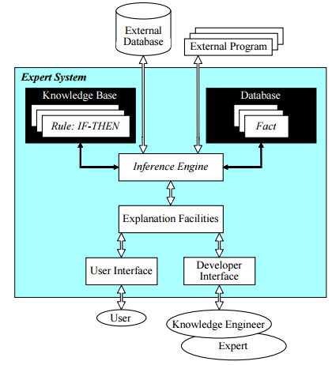

Q4.What is meta-knowledge? Give an example.

knowledge about knowledge

Q5. Why is knowledge acquisition often referred to as the ES 'bottleneck'?

Q6. Describe at least 3 advantages that expert systems offer organisations that would otherwise have to employ human experts.

Q7. Forward Chaining and Backward Chaining are two inferencing methods for rules, each is commonly used for different problem types. Describe a problem you would use each for.

Q8. Discuss the main differences between forward chaining and backward chaining.

forward chaining: Data-driven search

backward chaining: Goal-driven search

Q9. What are the advantages of using a rule-based system like Prolog to infer over a rule set rather than coding the rules directly as IF-THEN-ELSE statements in a programming language like Java?

Q10. Semantic network is a useful tool for knowledge representation. Create a semantic network to describe a car. Your network should include the concepts: car,person, driver, engine, petrol, petrol tank,and road.

Q11. Create a semantic network to describe a University course. Your network should include the concepts: course, title, department, faculty, student, lecturer and pre-requisite.

Q12. Consider the following production rule:

IF green THEN walk

a) What is the antecedent of this rule?

b) What is the consequent of this rule?

c) Which part of the rule will be matched against the working memory in case of forward chaining?

d) And in case of backward chaining?

Q13. The following is the rule set of a simple weather forecast expert system: R1 - IF cyclone THEN clouds

R2 - IF anticyclone THEN clear sky

R3 - IF pressure is low THEN cyclone

R4 - IF pressure is high THEN anticyclone R5 - IF arrow is down THEN pressure is low R6 - IF arrow is up THEN pressure is high

a) Use forward chaining to reason about the weather if the working memory contains the fact: arrow is down. Show your answer in a table naming the rules matching the current working memory (conflict set), which rule you apply, and how the working memory contents changes on the next cycle after a rule has fired:

b) Use backward chaining to reason about the weather if the working memory contains the fact: clouds. Show your answer in a similar table.

c) Suppose that the user interface of our ES allows the system to ask a user about the facts whether they are true or false. What question (or questions) the system should ask the user in order to conclude that the sky is clear? What will the user answer? Which rule will require the clarification from the user?

Q14. Consider the following familiar set of rules: R1 - IF green THEN walk

R2 - IF red THEN wait

R3 - IF green AND blinking THEN hurry

R4 - IF red OR green THEN traffic light works

a) Which of the above rules will be put into a conflict set by the system if the working memory contains two facts: green, blinking ? Explain why each rule is selected or not.

b) Which of the rules would fire if we used the specificity conflict resolution strategy? Explain why.

Q15. What kind of mistakes might ES make and why?

Q16. Explore the literature to identify the major problems in getting AI applications accepted. What is required on the part of management?

(Tips: Some problems would include: cost, executive support, security, or human aspect.)